NAME: FAHAD KHAN
ROLL NO :23-SE-64

TASK 1

clc; clear; close all;

% Read image
A = imread('rice.png');

% Display original
figure, imshow(A);
title('Original Image');

% Negation Transformation
L = 256;
S = (L - 1) - A;

% Display negative image
figure, imshow(S);
title('Negative Image (S = 255 - r)');
OUTPUT:

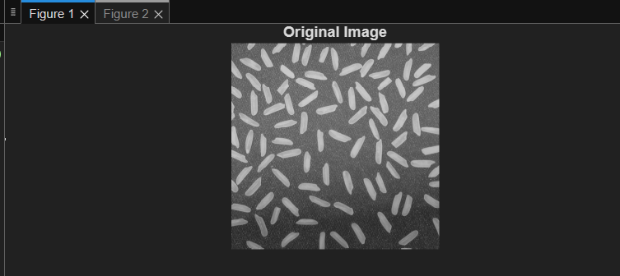

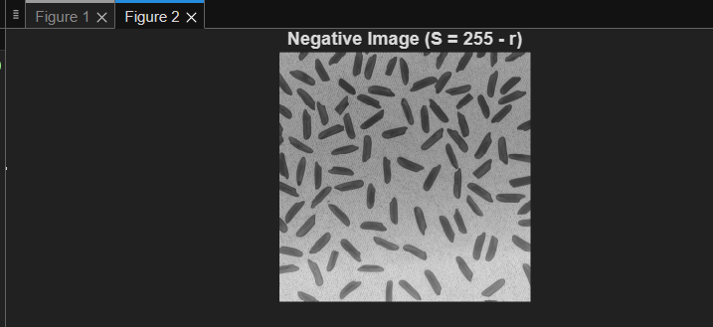
TASK 2:
clc; clear; close all;

A = imread('rice.png');
figure, imshow(A);
title('Original Image');

% Convert to double
r = double(A);

% Constant
C = 1;

% Apply log transform
S = C * log(1 + r);

% Normalize to [0 255]
Temp = 255 / (C * log(256));
B = uint8(Temp * S);

% Display result
figure, imshow(B);

OUTPUT:

title('Log Transformation');
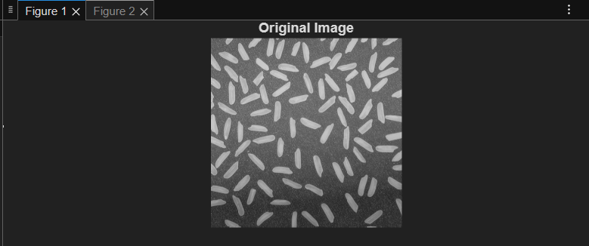
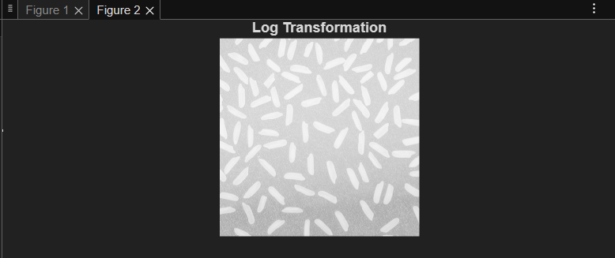

TASK 3:
clc; clear; close all;

I = imread('cameraman.tif');
J = double(I);

[row, col] = size(J);

T1 = input('Enter lower threshold: ');
T2 = input('Enter upper threshold: ');

for i = 1:row
for j = 1:col
if (J(i,j) > T1 && J(i,j) < T2)
J(i,j) = 255;
else
J(i,j) = I(i,j); % keep background
end
end
end

figure, imshow(I);
title('Original Image');

figure, imshow(uint8(J));
title('Gray Level Slicing (With Background)');

OUTPUT:
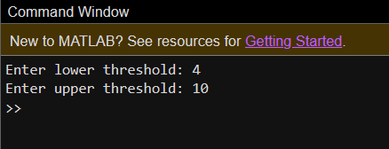

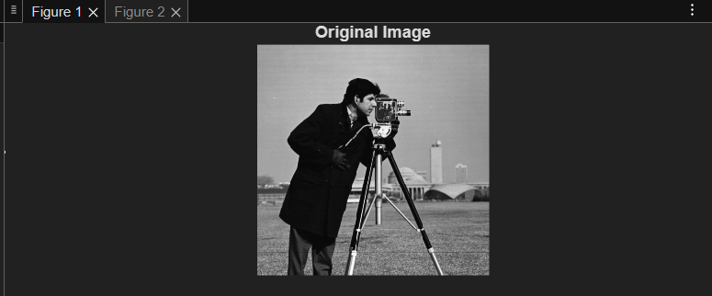
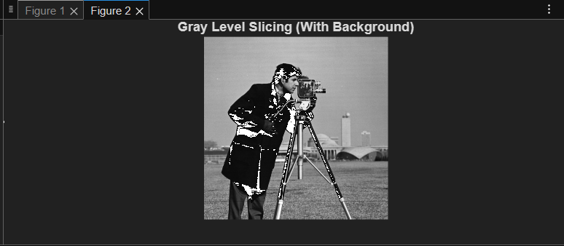

Without BAckground
clc; clear; close all;

I = imread('cameraman.tif');
J = double(I);

[row, col] = size(J);

for i = 1:row
for j = 1:col
if (J(i,j) > 80 && J(i,j) < 150)
J(i,j) = 255;
else
J(i,j) = 0;
end
end
end

subplot(1,2,1);
imshow(I);
title('Original Image');

subplot(1,2,2);
imshow(uint8(J));
title('Gray Level Slicing (Without Background)');

OUTPUT:
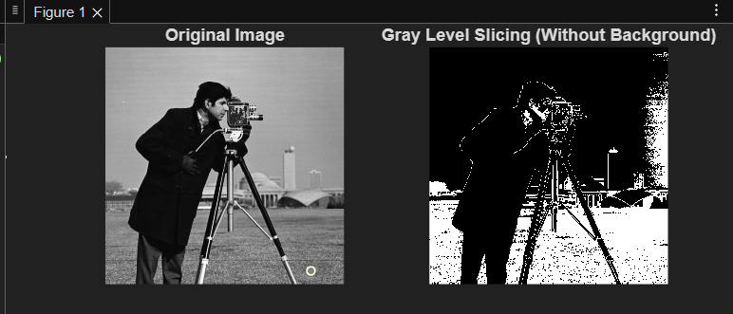

TASK 4 : Bit plane slicing
clc; clear; close all;

A = imread('coins.png');

figure;

for k = 1:8
B = bitget(A, k);
subplot(2,4,k);
imshow(logical(B));
title(['Bit Plane ', num2str(k)]);
end

OUTPUT:
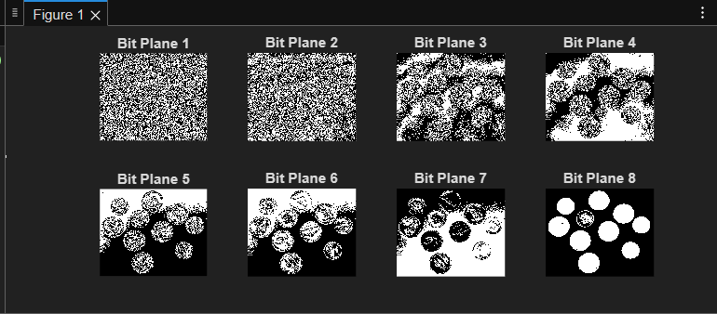

Task- 5: Gamma Tranformation
clc; clear; close all;

A = imread('rice.png');
figure, imshow(A);
title('Original Image');

% Convert to double
r = double(A);

% Constants
C = 1;
G = 0.40; % Gamma value

% Power law transformation
S = C * (r .^ G);

% Normalize
Temp = 255 / (C * (255 ^ G));
S1 = uint8(Temp * S);

figure, imshow(S1);
title('Gamma Corrected Image (Gamma = 0.40)');

OUTPUT:
